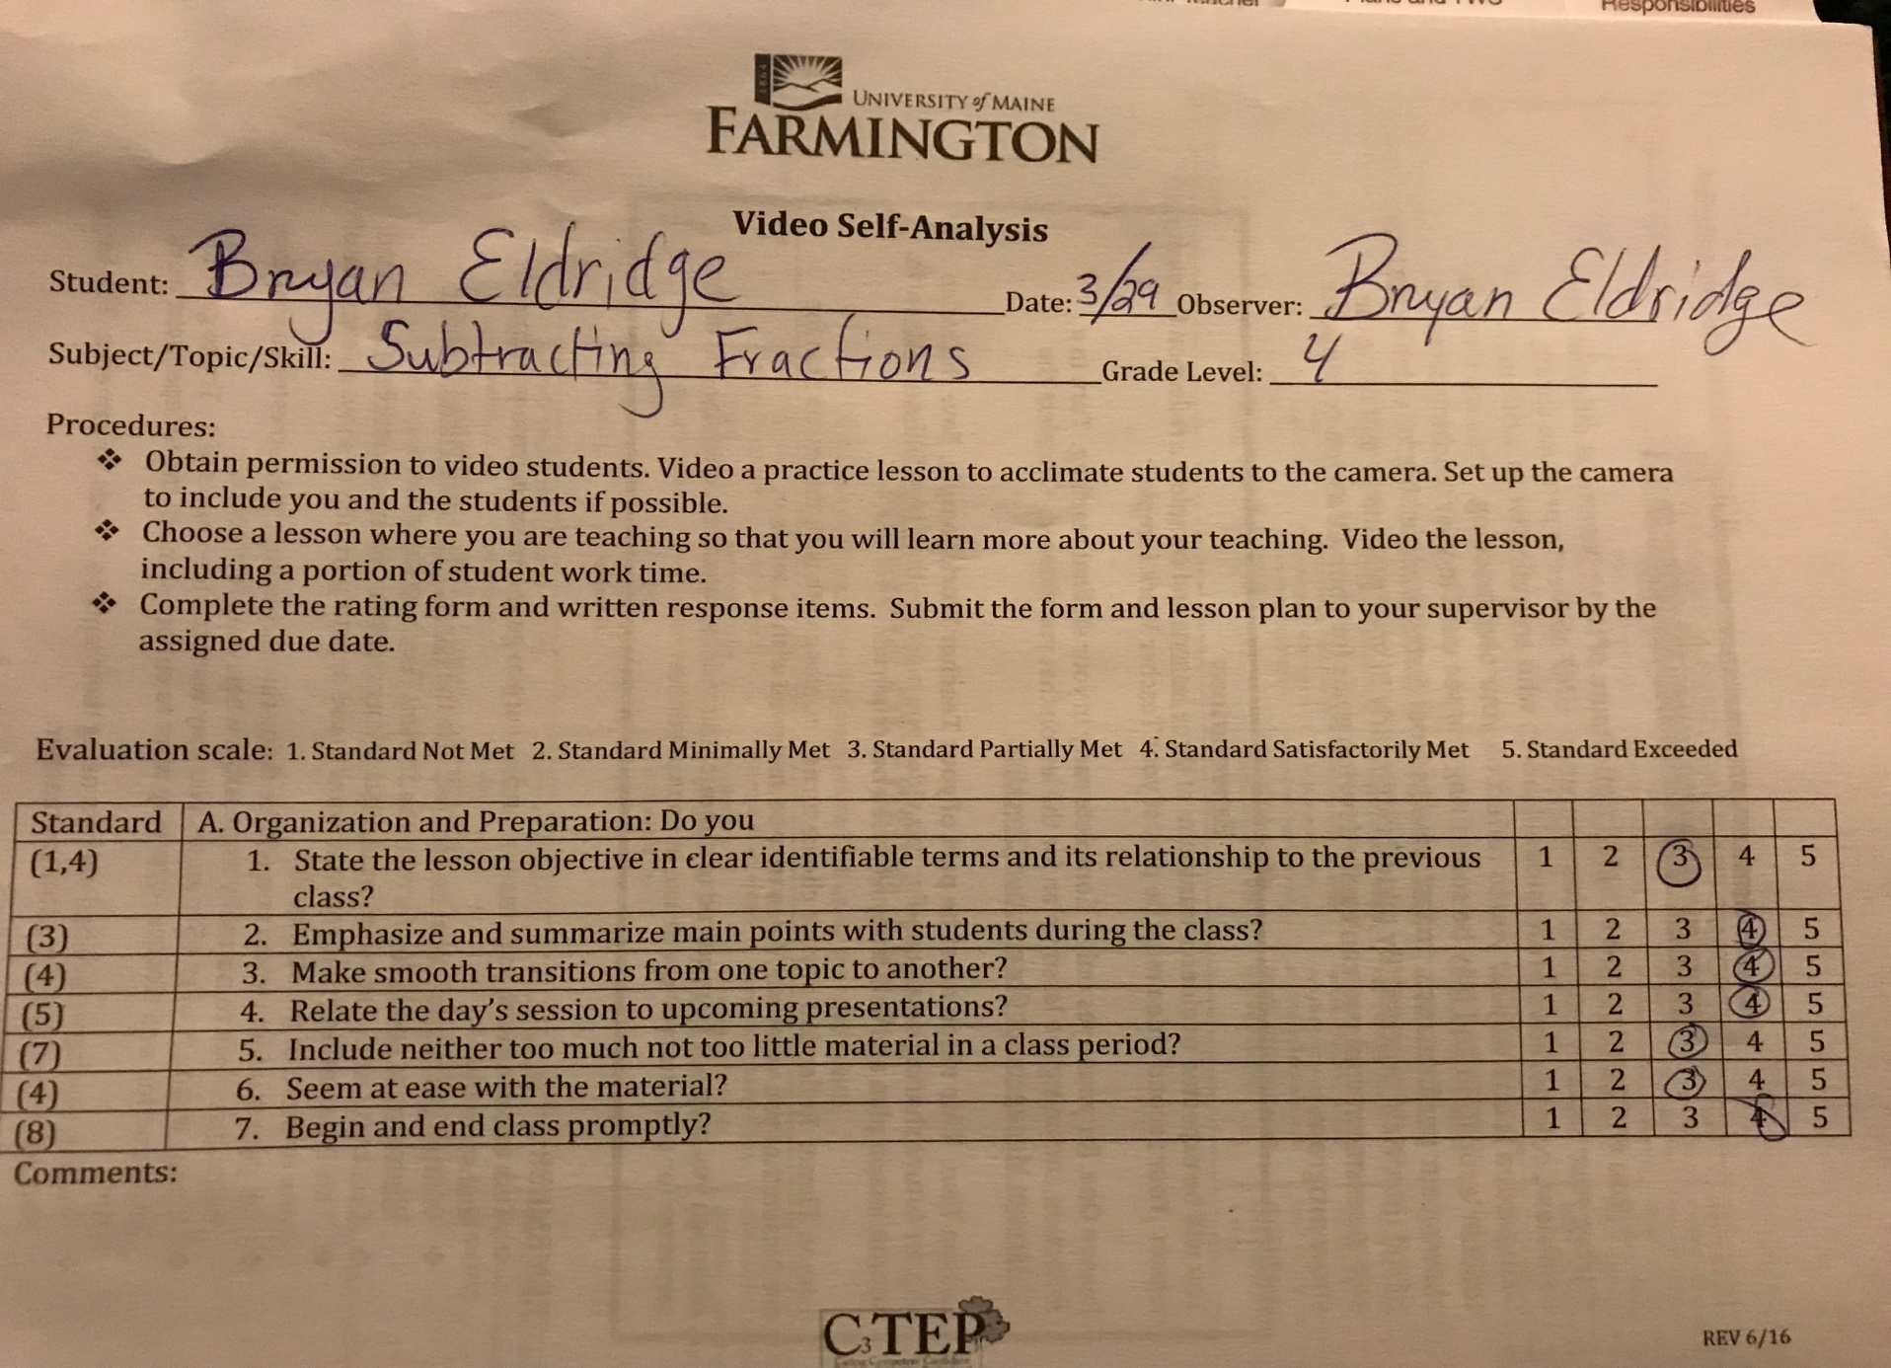

Each day started with a discussion of the previous material before beginning the new lesson. I always made sure that I emphasized the main ideas of the lesson, though I could work on including material more specific to the worksheets they’d be filling out.

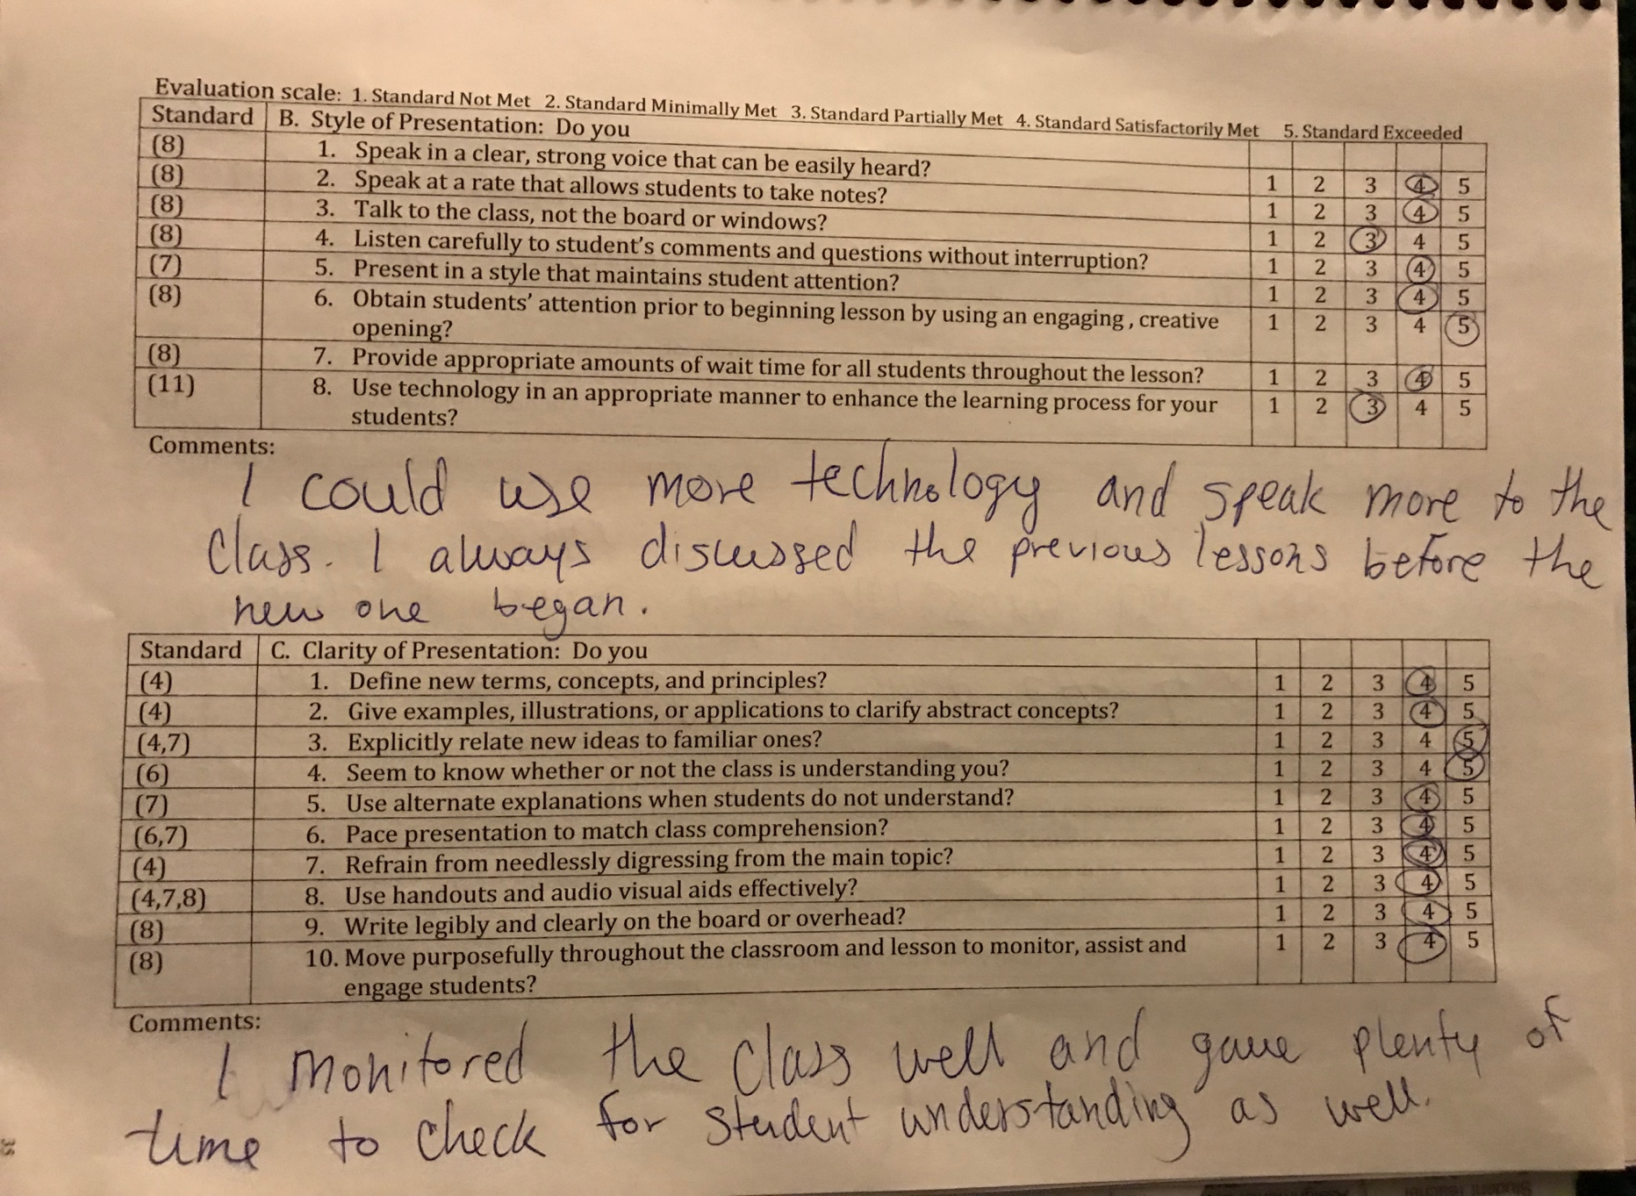

While more technology could have been incorporated, I feel as though the class had sufficient resources to meet the objectives. I need to work on speaking more to the class and incorporating wait time, but I monitored the class consistently and effectively.

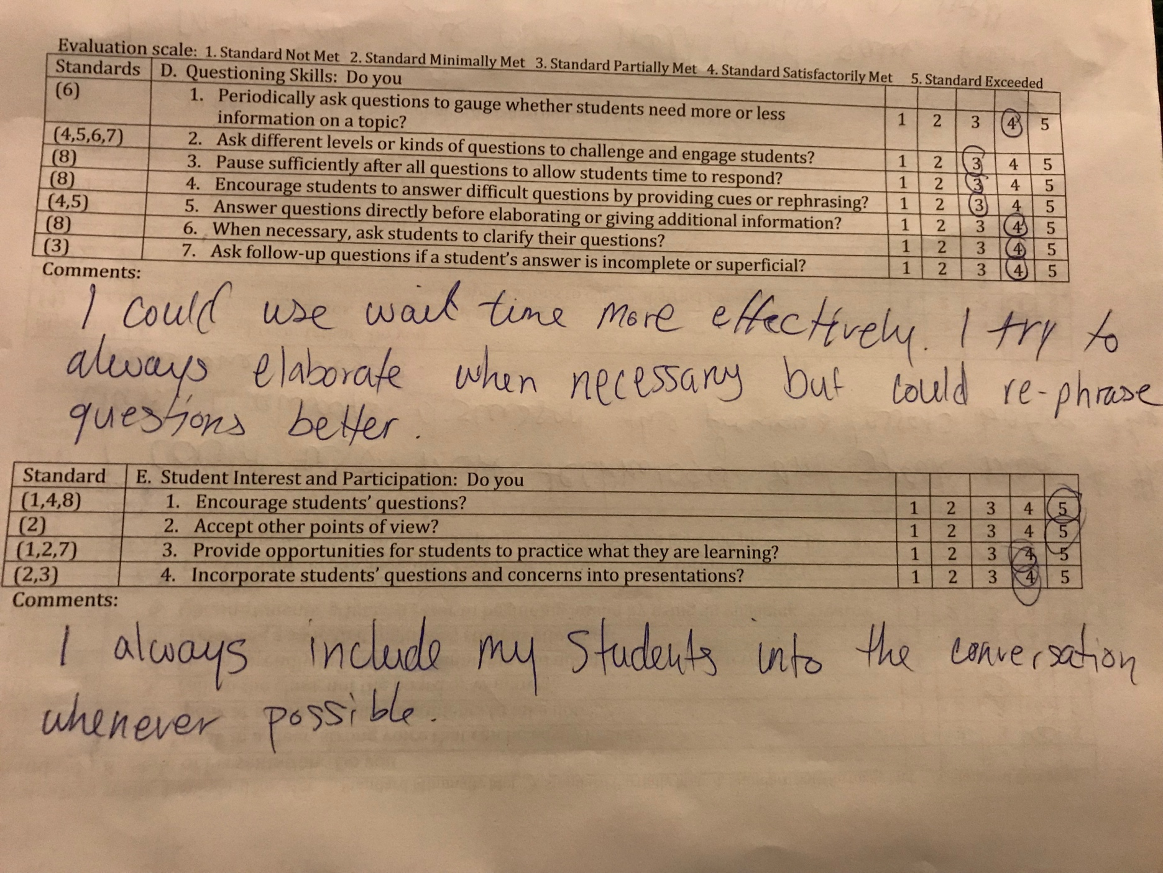

I did well to elaborate on all the necessary material for the lesson and made sure to ask plenty of questions for the class to answer. The students were in turn included but could benefit from a varying degree of questions.

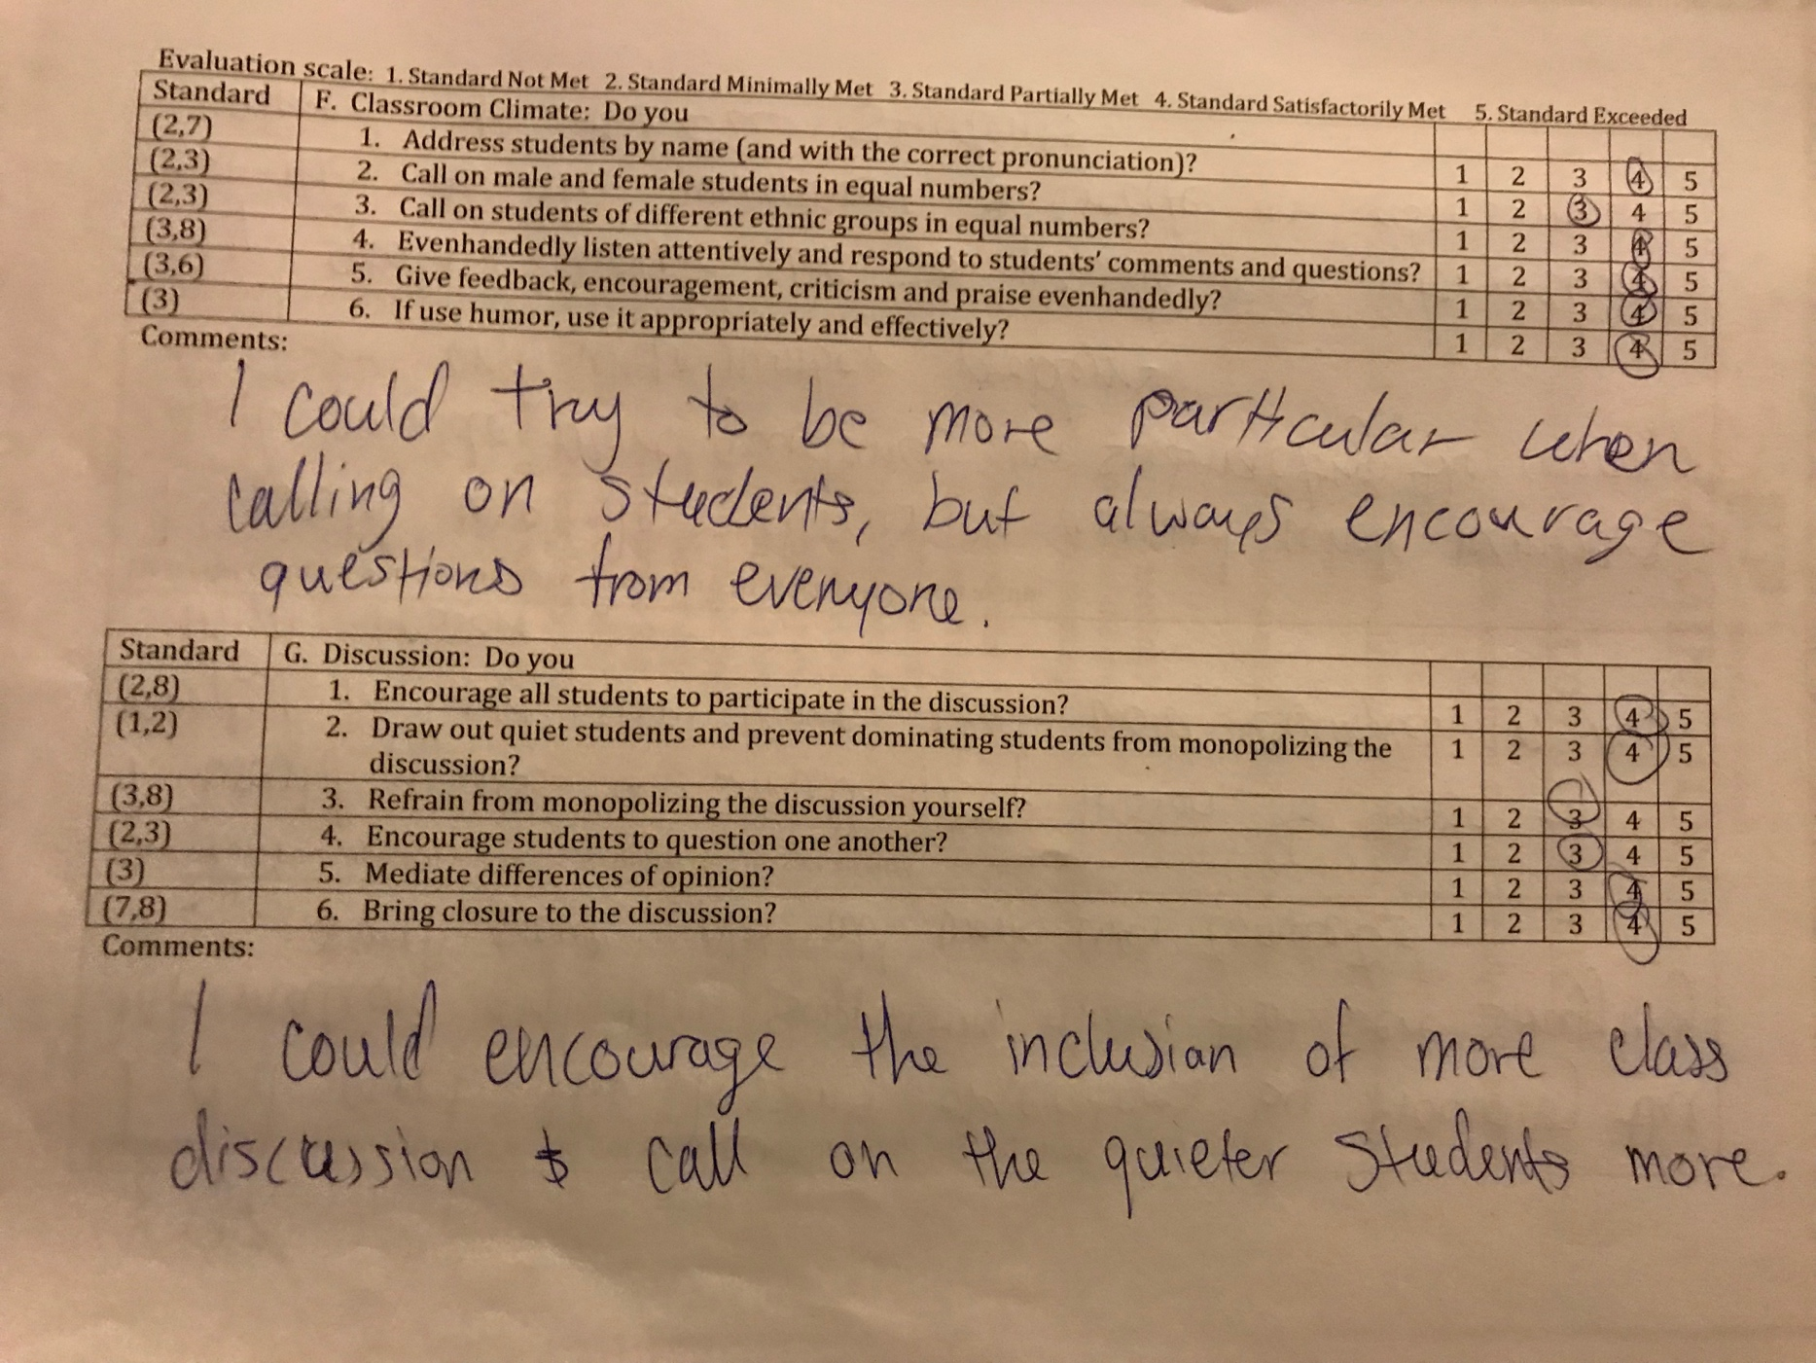

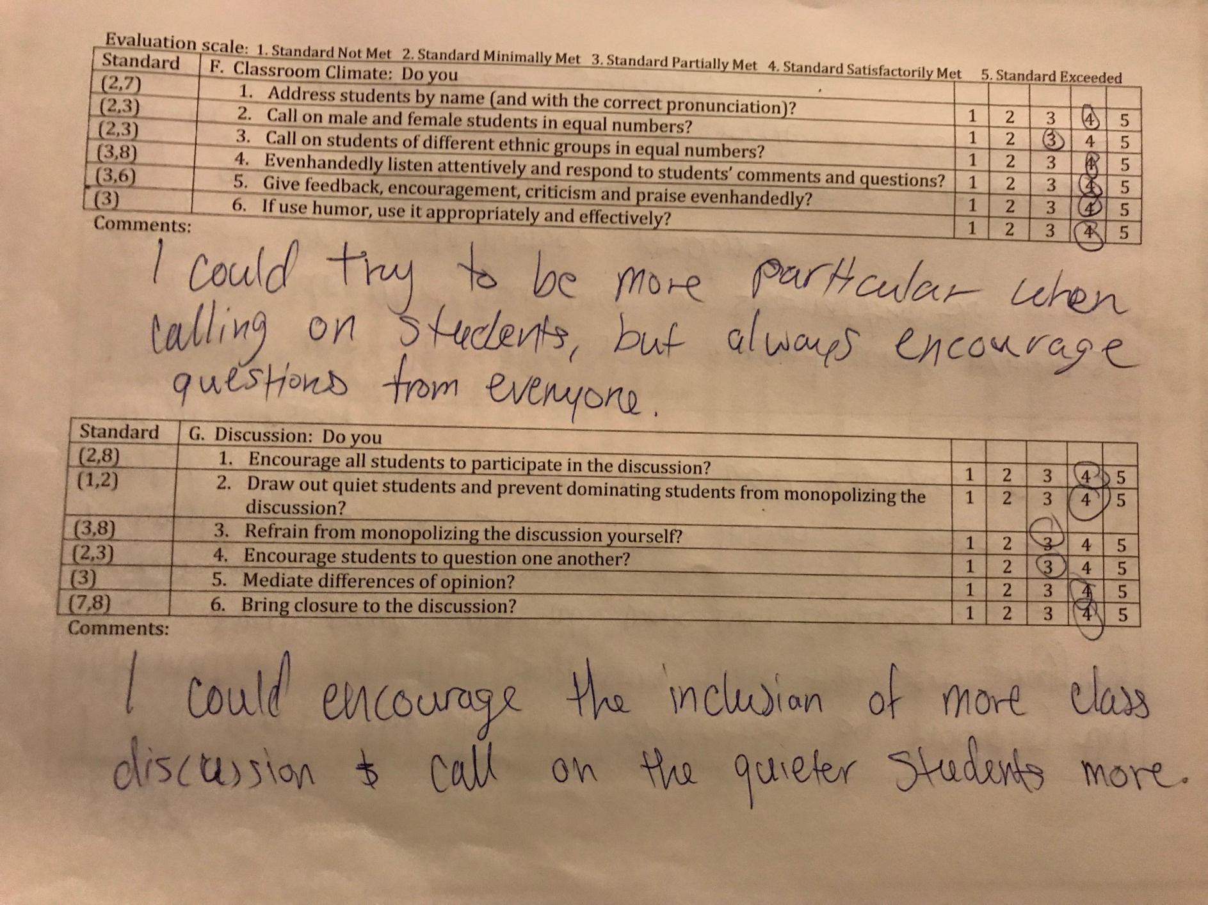

My questions could center more around including my quieter students as well as fostering more discussion around the mini-lesson material. Various questions are always included into my lessons and I do encourage all students to actively participate in the discussion.

